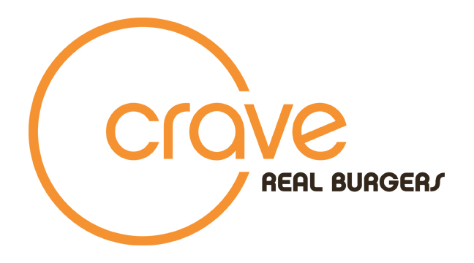
Eligibility: Challenge is open to all 18 years and older.

PLEASE READ CAREFULLY and INITIAL by each bullet point:

So you think you have what it takes to master the BIG BAD WOLF or el LOBO FEROZ challenge?
Here’s how the Big Bad Wolf/el Lobo Feroz Challenges work and the basic rules for participating:

- We serve the Challenger, one person only, 2 loaded 3 Little Pigs Burgers (Big Bad Wolf) with green chili cheese fries or 2 loaded Cubano burgers (el Lobo Feroz) and green chili cheese fries . The challenge is the challenge and no modifications are allowed. You will be seated with no bags, purses, jackets around you. If you cheat, you lose and we got eyes everywhere. Play fair!

- Then we set the timer to 30 minutes. The Wolf Challenger Huffs and Puffs and attempts to wolf down everything on the plate, in 30 minutes, without any restroom breaks. If you barf, you lose. And you will be provided cleaning supplies and you agree to clean it up, because we ain’t gonna! If you go outside or to the restroom, you lose.

- If the Wolf Challenger conquers the 3 Little Pigs (Big Bad Wolf) and fries or the Cubanos (el Lobo Feroz) and fries, the meal is free, his/her photo is proudly displayed on our Wall of Winners on the Crave Real Burgers website, www.craverealburgers.com and he/she gets a free Challenger T-shirt!! If the Challenger should fail the price is $35.00 and a photo on the Wall of Losers on the Crave Real Burgers website, www.craverealburgers.com. Participant agrees to allow Crave Real Burgers to use the photo in social media and other promotional materials.

- Participant is limited to one successful challenge per year which covers all Crave Real Burgers locations.

ACKNOWLEDGEMENT OF RULES AND WAVIER OF LIABILITY:
Contestant agrees to the above rules of participation. Contestant acknowledges that there are risks of personal injury and/or illness. The challenger, as a condition of entry, agrees to hold harmless Crave Real Burgers, Brother & Brother LLC, Brother & Brother CS LLC, Brother & Brother Ranch LLC , Crave Management, LLC and any of their affiliated vendors or employees, from any and all claims and costs, including attorney fees, medical fees relating to, arising from the original connection with participation in the BIG BAD WOLF or el LOBO FEROZ challenge.

PRINT name of participant: _________________________________________

Signature of participant : _____________________________________________

Date:________________________________________

